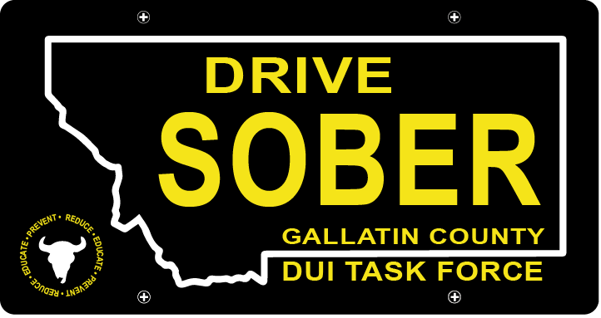

Gallatin County DUI Task Force

Meeting

Wednesday, March 20, 2024 @ 5:30 pm
Courthouse 3rd Floor Community Room: 311 West Main Street, Bozeman, MT

Join Zoom Meeting
Meeting ID: 473 409 9336
Passcode: DUITF24

- Call to order
- Approval of Minutes
- Update
  - Member Update
  - DUI Report – Update
- Speaker: MSU Dean of Students
- New business
    - April Law Enforcement Award Ceremony
      - Commitment from 2/6 agencies, waiting to hear from the rest.
      - Sponsor Donations
        - Vortex agreed to donate items.
        - Assignments
      - Logistics: April 17th at 6:00PM, set up at 5
    - Budget
      - Coordinator Position Discussion
    - Summer Events
      - Catapalooza registration in May
      - Music on Main Dates: July 11, July 18, July 25, August 1, August 8, August 15
- Public Comment
- Adjournment
Adjourned meeting at _________.

